Implement Snowflake Streams for Sales Data Processing
A retail company receives sales data in a staging table. The company wants to load this data into a final reporting table. After the initial load, only newly inserted or updated records should be processed using Snowflake Streams.
You need to create the database, tables, stream object, insert records, consume stream data, and update the final table using stream changes.

Task 1: Create Database
Create a transient database named:
STREAMS_DB

CREATE OR REPLACE TRANSIENT DATABASE STREAMS_DB;

Task 2: Create Raw Sales Staging Table
Create a table named:
SALES_RAW_STAGING

The table should contain the following columns:
Id, product, price, amount, store_id

Use suitable data types.

CREATE OR REPLACE TABLE STREAMS_DB.PUBLIC.SALES_RAW_STAGING
(
ID INT,
PRODUCT STRING,
PRICE FLOAT,
AMOUNT INT,
STORE_ID INT
);

Task 3: Insert Initial Sales Data
Insert the following five records into SALES_RAW_STAGING:
id product price amount store_id
1 Banana 1.99 1 1
2 Lemon 0.99 1 1
3 Apple 1.79 1 2
4 Orange Juice 1.89 1
5 Cereals 5.98 2 1

INSERT INTO STREAMS_DB.PUBLIC.SALES_RAW_STAGING VALUES
(1,'Banana',1.99,1,1),
(2,'Lemon',0.99,1,1),
(3,'Apple',1.79,1,2),
(4,'Orange Juice',1.89,1,NULL),
(5,'Cereals',5.98,2,1);
Task 4: Create Store Table
Create a table named:
STORE_TABLE

The table should contain:
store_id, location, employees

CREATE OR REPLACE TABLE STREAMS_DB.PUBLIC.STORE_TABLE
(
STORE_ID INT,
LOCATION STRING,
EMPLOYEES INT
);

Task 5: Insert Store Data
Insert the following records into STORE_TABLE:
store_id location employees
1 Chicago 33
2 London 12

INSERT INTO STREAMS_DB.PUBLIC.STORE_TABLE VALUES
(1,'Chicago',33),
(2,'London',12);

Task 6: Create Final Sales Table
Create a table named:

SALES_FINAL_TABLE

The table should contain:
Id, product, Price, amount, store_id, location, employees
This table will store sales data along with store location and employee details.

CREATE OR REPLACE TABLE STREAMS_DB.PUBLIC.SALES_FINAL_TABLE
(
ID INT,
PRODUCT STRING,
PRICE FLOAT,
AMOUNT INT,
STORE_ID INT,
LOCATION STRING,
EMPLOYEES INT
);

Task 7: Perform Initial Full Load
Load data from SALES_RAW_STAGING into SALES_FINAL_TABLE.
While loading, join:
SALES_RAW_STAGING
with:
STORE_TABLE
using STORE_ID.

INSERT INTO STREAMS_DB.PUBLIC.SALES_FINAL_TABLE
SELECT
R.ID,
R.PRODUCT,
R.PRICE,
R.AMOUNT,
R.STORE_ID,
S.LOCATION,
S.EMPLOYEES
FROM STREAMS_DB.PUBLIC.SALES_RAW_STAGING R
LEFT JOIN STREAMS_DB.PUBLIC.STORE_TABLE S
ON R.STORE_ID = S.STORE_ID;

Task 8: Verify Initial Load
Display data from:
SALES_RAW_STAGING; STORE_TABLE; SALES_FINAL_TABLE;
Confirm that SALES_FINAL_TABLE contains 5 records.
SELECT * FROM STREAMS_DB.PUBLIC.SALES_RAW_STAGING;
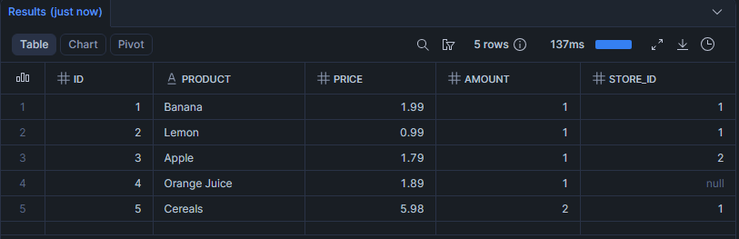
SELECT * FROM STREAMS_DB.PUBLIC.STORE_TABLE;
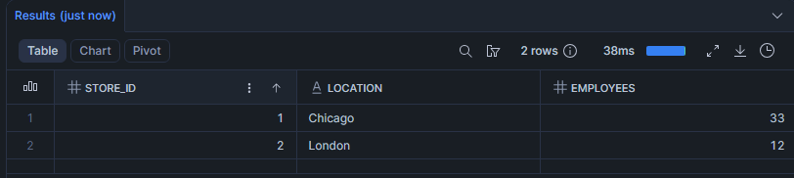
SELECT * FROM STREAMS_DB.PUBLIC.SALES_FINAL_TABLE;
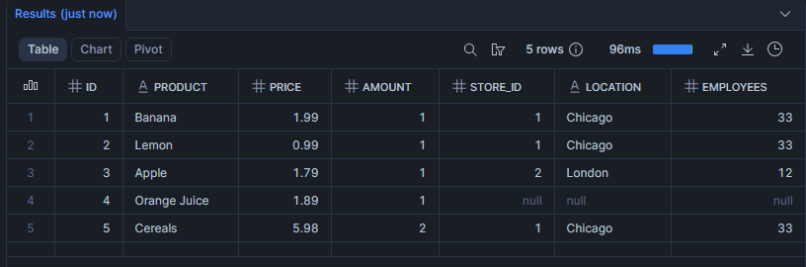

Stream Implementation
Task 9: Create Stream Object
Create a stream named:
SALES_STREAM
on top of:
SALES_RAW_STAGING

CREATE OR REPLACE STREAM SALES_STREAM
ON TABLE STREAMS_DB.PUBLIC.SALES_RAW_STAGING;

Task 10: View Stream Information
Execute commands to:
Show all streams.
Describe the SALES_STREAM.
Select data from SALES_STREAM.

SHOW STREAMS;
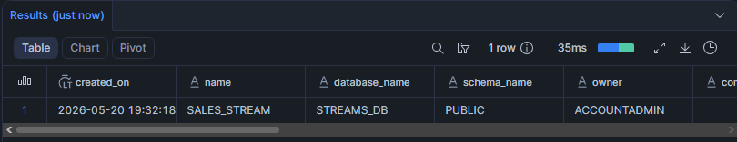
DESC STREAM SALES_STREAM;

SELECT * FROM SALES_STREAM;
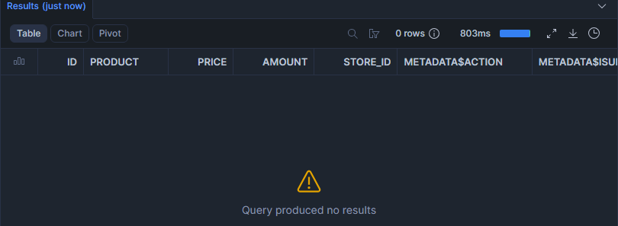
Answer this question:
Why is SALES_STREAM empty immediately after creation?
It’s empty because streams only capture changes that happen on the table its created on. Since, no changes happened on the table after creation its empty

Insert Change Capture
Task 11: Insert New Sales Records
Insert the following two records into SALES_RAW_STAGING:
id product price amount store_id
6 Mango 1.99 1 2
7 Garlic 0.99 1 1

INSERT INTO STREAMS_DB.PUBLIC.SALES_RAW_STAGING VALUES
(6,'Mango',1.99,1,2),
(7,'Garlic',0.99,1,1);

Task 12: Check Stream Data
Query SALES_STREAM.
Observe the new records and metadata columns:
METADATA$ACTION
METADATA$ISUPDATE
METADATA$ROW_ID

SELECT * FROM STREAMS_DB.PUBLIC.SALES_STREAM;
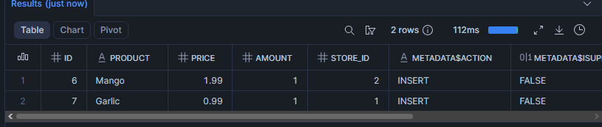
Answer this question:
What value do you see in METADATA$ACTION for newly inserted records?
For the newly inserted records in SALES_STREAM we see INSERT value under METADATA$ACTION. Because, we used the insert operation to insert that data in the STAGING table.

Task 13: Verify Source and Target Tables
Check data in:
SALES_RAW_STAGING;
SALES_FINAL_TABLE;

SELECT * FROM STREAMS_DB.PUBLIC.SALES_RAW_STAGING;
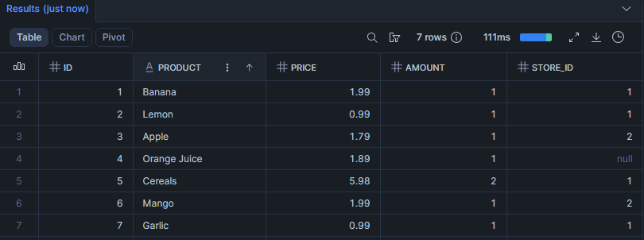
SELECT * FROM STREAMS_DB.PUBLIC.SALES_FINAL_TABLE;
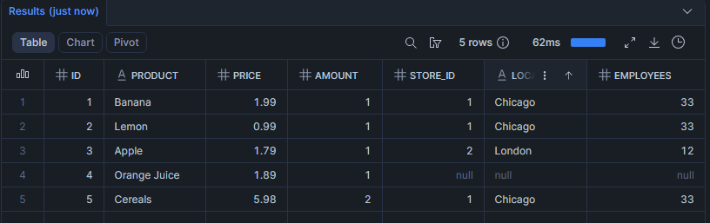
Answer this question:
Are the new records available in SALES_FINAL_TABLE before consuming the stream?
No, The new records are not available in SALES_FINAL_TABLE without consuming the stream.

Task 14: Consume Stream Data
Insert new records from SALES_STREAM into SALES_FINAL_TABLE.
While inserting, join the stream with STORE_TABLE using STORE_ID.

INSERT INTO STREAMS_DB.PUBLIC.SALES_FINAL_TABLE
SELECT
S.ID,
S.PRODUCT,
S.PRICE,
S.AMOUNT,
S.STORE_ID,
ST.LOCATION,
ST.EMPLOYEES
FROM STREAMS_DB.PUBLIC.SALES_STREAM S
LEFT JOIN STREAMS_DB.PUBLIC.STORE_TABLE ST
ON S.STORE_ID = ST.STORE_ID
WHERE METADATA$ACTION='INSERT';

Task 15: Verify Stream After Consumption
Query:
SELECT * FROM STREAMS_DB.PUBLIC.SALES_STREAM; 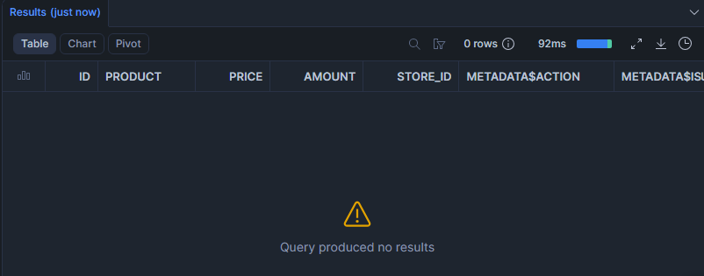
Answer this question:
Why did the stream become empty after inserting data into SALES_FINAL_TABLE?
The stream is empty because the changes were consumed and there are no new changes.

Second Insert Change Capture
Task 16: Insert More Sales Records
Insert the following two records into SALES_RAW_STAGING:
id product price amount store_id
8 Paprika 4.99 1 2
9 Tomato 3.99 1 2

INSERT INTO STREAMS_DB.PUBLIC.SALES_RAW_STAGING VALUES
(8,'Paprika',4.99,1,2),
(9,'Tomato',3.99,1,2);

Task 17: Consume Second Stream Data
Consume the newly captured stream records and insert them into SALES_FINAL_TABLE.

INSERT INTO STREAMS_DB.PUBLIC.SALES_FINAL_TABLE
SELECT
S.ID,
S.PRODUCT,
S.PRICE,
S.AMOUNT,
S.STORE_ID,
ST.LOCATION,
ST.EMPLOYEES
FROM STREAMS_DB.PUBLIC.SALES_STREAM S
LEFT JOIN STREAMS_DB.PUBLIC.STORE_TABLE ST
ON S.STORE_ID = ST.STORE_ID
WHERE METADATA$ACTION='INSERT';

Task 18: Verify Final Insert Output
Display data from:
SALES_FINAL_TABLE; SALES_RAW_STAGING; SALES_STREAM;

SELECT * FROM STREAMS_DB.PUBLIC.SALES_FINAL_TABLE;
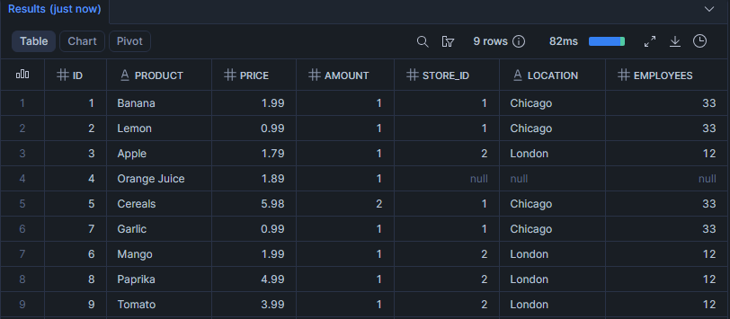
SELECT * FROM STREAMS_DB.PUBLIC.SALES_RAW_STAGING;
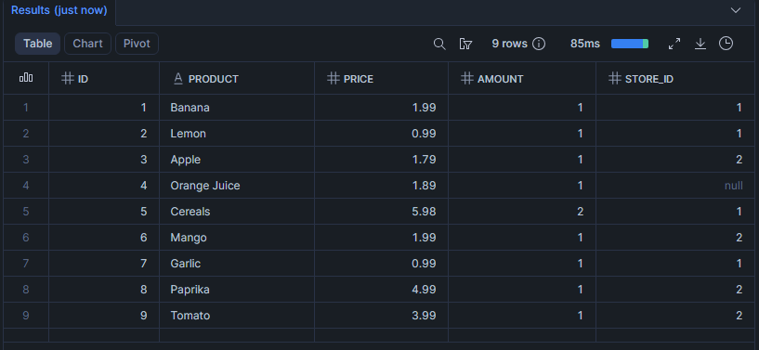

SELECT * FROM STREAMS_DB.PUBLIC.SALES_STREAM;
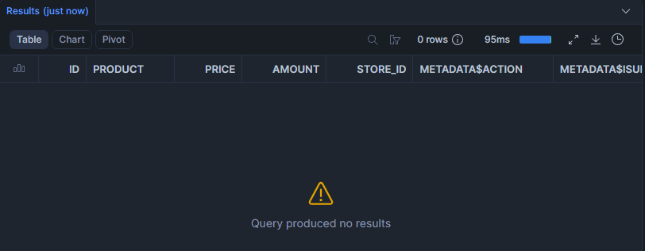
Answer:
How many records are now available in SALES_FINAL_TABLE?
There are now 9 records available in SALES_FINAL_TABLE.

Update Change Capture
Task 19: Check Existing Data Before Update
Display records from:
SALES_RAW_STAGING; SALES_STREAM;
SELECT * FROM STREAMS_DB.PUBLIC.SALES_RAW_STAGING;
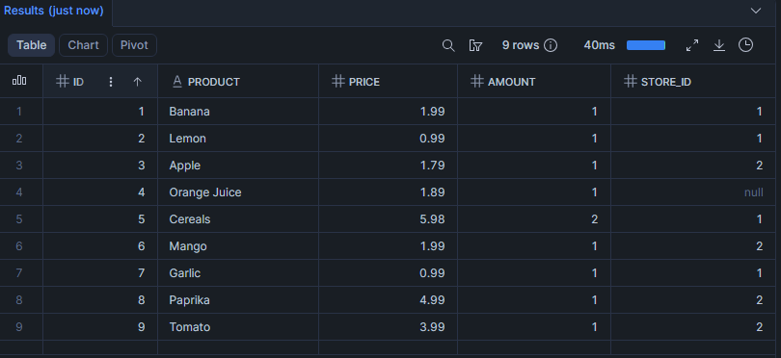
SELECT * FROM STREAMS_DB.PUBLIC.SALES_STREAM;


Task 20: Perform First Update
Update the product name:
Banana to: Potato
in SALES_RAW_STAGING.

UPDATE STREAMS_DB.PUBLIC.SALES_RAW_STAGING
SET PRODUCT='Potato'
WHERE PRODUCT='Banana';

Task 21: Check Stream After Update
Query:
SELECT * FROM STREAMS_DB.PUBLIC.SALES_STREAM;
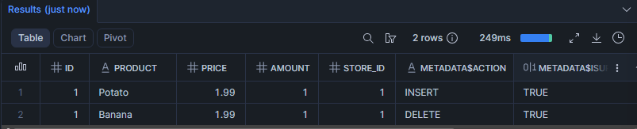
Answer:
How does Snowflake represent an UPDATE operation inside a stream?
Snowflake represents an UPDATE operation as a DELETE and INSERT operation in the stream. It deletes the value and inserts new value as update.

Task 22: Consume Update Using MERGE
Use a MERGE statement to update the corresponding record in SALES_FINAL_TABLE.
Condition:
Match records using ID
Update only records where METADATA$ACTION = 'INSERT'
and METADATA$ISUPDATE = TRUE

Update the following columns:
Product price amount store_id

MERGE INTO SALES_FINAL_TABLE T
USING (
SELECT
S.ID,
S.PRODUCT,
S.PRICE,
S.AMOUNT,
S.STORE_ID
FROM SALES_STREAM S
LEFT JOIN STORE_TABLE ST
ON S.STORE_ID = ST.STORE_ID
WHERE METADATA$ACTION = 'INSERT'
AND METADATA$ISUPDATE = TRUE
) SRC

ON T.ID = SRC.ID

WHEN MATCHED THEN
UPDATE SET
T.PRODUCT = SRC.PRODUCT,
T.PRICE = SRC.PRICE,
T.AMOUNT = SRC.AMOUNT,
T.STORE_ID = SRC.STORE_ID

Task 23: Verify First Update
Display data from:
SALES_FINAL_TABLE; SALES_RAW_STAGING; SALES_STREAM;

SELECT * FROM STREAMS_DB.PUBLIC.SALES_FINAL_TABLE;
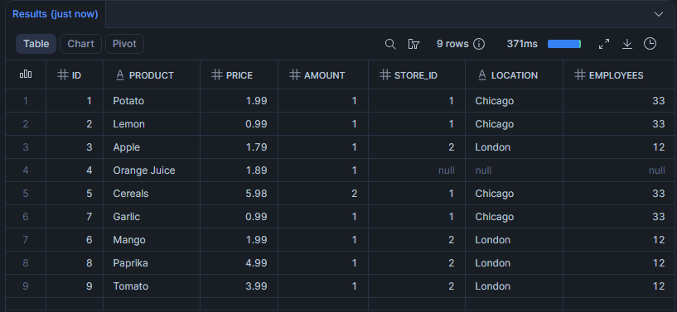
SELECT * FROM STREAMS_DB.PUBLIC.SALES_RAW_STAGING;
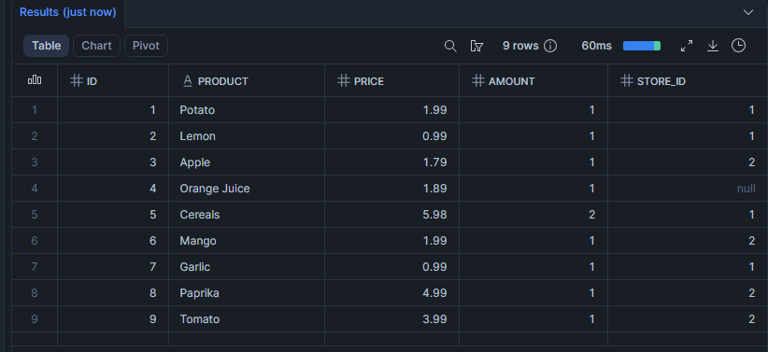
SELECT * FROM STREAMS_DB.PUBLIC.SALES_STREAM;
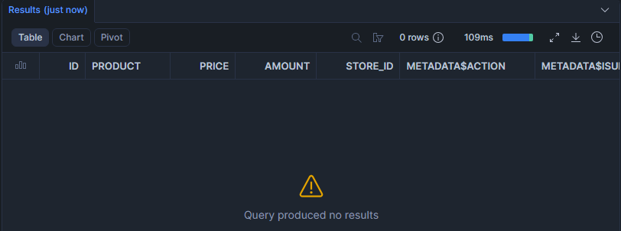
Answer:
Is Banana changed to Potato in SALES_FINAL_TABLE?
Yes, Banana is changed to Potato in SALES_FINAL_TABLE.

Second Update Change Capture
Task 24: Perform Second Update
Update the product name:
Apple to: Green apple
in SALES_RAW_STAGING.

UPDATE STREAMS_DB.PUBLIC.SALES_RAW_STAGING
SET PRODUCT='Green apple'
WHERE PRODUCT='Apple';

Task 25: Consume Second Update Using MERGE
Use a MERGE statement to update the changed record in SALES_FINAL_TABLE.
MERGE INTO SALES_FINAL_TABLE T
USING (
SELECT
S.ID,
S.PRODUCT,
S.PRICE,
S.AMOUNT,
S.STORE_ID
FROM SALES_STREAM S
LEFT JOIN STORE_TABLE ST
ON S.STORE_ID = ST.STORE_ID
WHERE METADATA$ACTION = 'INSERT'
AND METADATA$ISUPDATE = TRUE
) SRC

ON T.ID = SRC.ID

WHEN MATCHED THEN
UPDATE SET
T.PRODUCT = SRC.PRODUCT,
T.PRICE = SRC.PRICE,
T.AMOUNT = SRC.AMOUNT,
T.STORE_ID = SRC.STORE_ID

Task 26: Verify Final Output
Display data from:
SALES_FINAL_TABLE; SALES_RAW_STAGING; SALES_STREAM;

SELECT * FROM STREAMS_DB.PUBLIC.SALES_FINAL_TABLE;
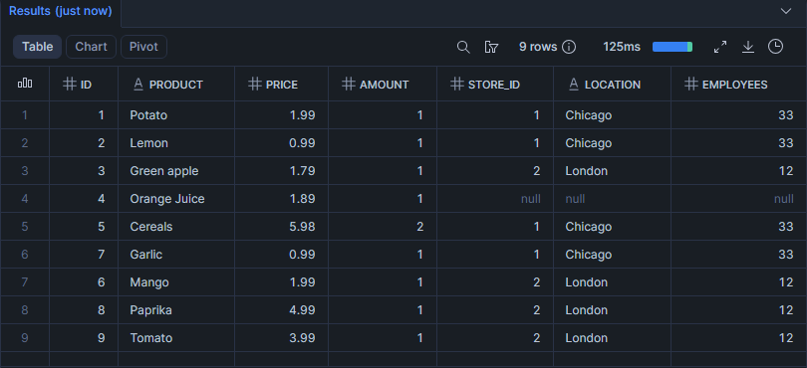
SELECT * FROM STREAMS_DB.PUBLIC.SALES_RAW_STAGING;
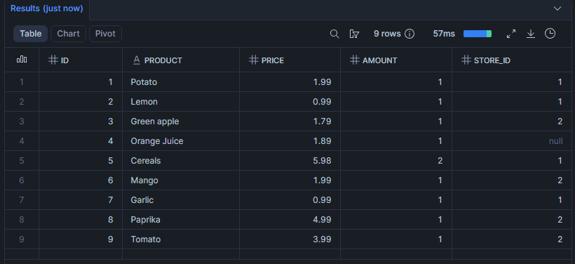
SELECT * FROM STREAMS_DB.PUBLIC.SALES_STREAM;
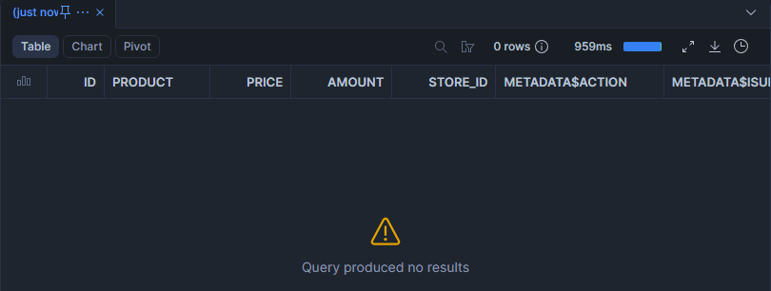
Answer:
Is Apple changed to Green apple in SALES_FINAL_TABLE?
Yes, Apple changed to Green apple in SALES_FINAL_TABLE.

